# Proposed Solution

The proposed solution would be as follows:

1) Open data contains a spreadsheet of the main 9 calendars:   <http://www1.toronto.ca/wps/portal/contentonly?vgnextoid=2ee34b5073cfa310VgnVCM10000071d60f89RCRD&vgnextchannel=1a66e03bb8d1e310VgnVCM10000071d60f89RCRD>

2) We copy this spreadsheet to a google drive and publish the "Master Calendar".

3) Once published, it is simply to read the calendar data in JSON format to be read by the front-end application. This spreadsheet can easily be maintained by SWM

For example:  <https://docs.google.com/spreadsheets/d/1KhilmUiWocTvXGpfIARlc-rcL8rRZJUqNyozcMer_iM/edit?usp=sharing>

→ there are alternative methods to create a JSON feed of the data, but this is the simplest.

In the Application:

4) The user enters his address and it is validated using 1-address APIs to obtain a lng/lat.

5) With the lng/lat we call the GCC API below which queries the garbage collection layer in GCC.

6) We take the "calendar" returned from API and match it to the spreadsheet data to come up with data to display in the form.

Issue 1:  As Scott has mentioned below, we "Solid Waste" should verify the layer in GCC is still correct.  We/Solid Waste will need to test border scenarios to make sure the API returns the correct calendar for those along border situations.

Issue 2:

The big issue is "Residential Unit above Commercial" or "Apartments above stores"

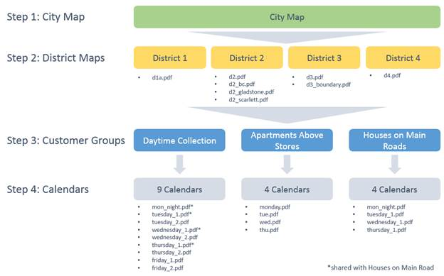

The open data spreadsheet doesn't contain the data for the 4 RUAC calendars. Monday.pdf, tue.pdf, wed.pdf, thu.pdf.

It wouldn't be hard to have it added except, the GCC API doesn't appear to contain the RUAC Data either.

Example:  2854 Dundas W has apartments over the commercial bottom according to this ad:  <https://www.walkscore.com/score/2854-dundas-st-w-toronto-on-canada>

Plugging 2854 Dundas W into the GCC api yields "Friday 1" with no apparent mention of the RUAC options  (which using the map below would be wed.pdf)

43.665699, -79.464515

<http://gis.toronto.ca/arcgis/rest/services/primary/cot_geospatial21_mtm/MapServer/3/query?where=&text=&objectIds=&time=&geometry=-79.464515%2C43.665699&geometryType=esriGeometryPoint&inSR=4326&spatialRel=esriSpatialRelWithin&relationParam=&outFields=AREA_ID%2CAREA_ATTR_ID%2CPARENT_AREA_ID%2CAREA_SHORT_CODE%2CAREA_NAME%2CAREA_DESC&returnGeometry=false&maxAllowableOffset=&geometryPrecision=&outSR=3857&returnIdsOnly=false&returnCountOnly=false&orderByFields=&groupByFieldsForStatistics=&outStatistics=&returnZ=false&returnM=false&gdbVersion=&returnDistinctValues=false&returnTrueCurves=false&resultOffset=&resultRecordCount=&f=pjson>

If I look at the RUAC collection map:

<http://www1.toronto.ca/city_of_toronto/solid_waste_management_services/apartments_and_condos/apartments_above_stores/files/pdf/night_map.pdf>

I need to look at this before determining which Calendar I use.

Is the information stored in this map available anywhere in GCC or elsewhere?

If not, can we create a GCC layer and an equivalent API to query it?

Or

Does it make sense to create this tool with a disclaimer that it is not applicable for "Apartments above Stores" and just exclude these people?

# Notes

The usage of the collection schedule "names" varies slightly in various environments.

In GCC from ArcGIS spatial query, the values are: Monday 1, Tuesday 2, etc.

In the spread Sheet copied to google the values are: Monday1,Tuesday2, etc.

The links for pdf end with: monday_1.pdf, tuesday_2.pdf, etc.